**PROJECT REPORT**

**ON**

**ONLINE BOOK STORE**

# Project-I

**Department of Computer Applications**

**CHANDIGARH GROUP OF COLLEGE JHANJERI, MOHALI**

**In partial fulfilment of the requirements for the award of the Degree of**

**Bachelor of graphics and web designing**

**SUBMITTED BY: Under the Guidance of**

Etendra Singh (2235955) Mr. Ravi Kumar

Mukul Aswal (2235972) Assistant Professor, CBS

Brij Kishor Pal (2235953)

Rohit Kumar (2235981)

DECEMBER 2024



**Affiliated to I.K Gujral Punjab Technical University, Jalandhar (Batch: 2022****_2025)**

# DECLARATION

I hereby certify that the project entitled “Online Book Store” submitted by Brij Kishore Pal (2235953), Etendra Singh (2235955), Mukul Aswal (2235972), Rohit Kumar (2235981) in partial fulfillment of the requirement for the award of degree of the BSC Graphics and Web Designing submitted in I.K. Gujral Punjab Technical University, Kapurthala at Chandigarh School of Business, Jhanjeri is an authentic record of my own work carried out during a period from January, 2024 to May, 2024 under the guidance of Prof. . The matter presented in this project has not formed the basis for the award of any other degree, diploma, fellowship or any other similar titles.

**Mukul Aswal** (2235972) 5th SEM

**Brij Kishore Pal** (2235953)5th SEM

**Rohit Kumar** (2231034) 5th SEM

**Etendra Singh** (2235955)5th SEM

# ACKNOWLEDGEMENT

It gives us great pleasure to deliver this report on the Project-I, We worked on for our BSc Graphics and Web Designing 3rd year, which was titled“Online Book Store”. We are grateful to our university for presenting us with such a wonderful and challenging opportunity. We also want to convey my sincere gratitude to all coordinators for their unfailing support and encouragement.

We are extremely thankful to the HOD and Project Coordinator of Computer Science & Engineering at Chandigarh School of Business, Jhanjeri, Mohali (Punjab) for valuable suggestions and heartiest co-operation.

We are also grateful to the management of the institute and Dr. Avinash, Director Engineering, for giving us the chance to acquire the information. We are also appreciative of all my faculty members, who have instructed us throughout our degree.

**Etendra singh**

**Brij Kishore Pal**

**Mukul Aswal**

**Rohit Kumar**

# ABSTRACT

The Online book store System is a cutting-edge project designed to enhance the personalized experience of book enthusiasts in the digital era. With the exponential growth of online libraries and bookstores, users often face the challenge of navigating through an overwhelming abundance of options. This project aims to alleviate this issue by leveraging advanced recommendation algorithms to provide users with tailored book suggestions based on their preferences. The system employs a collaborative filtering approach, combining user behaviour analysis and content-based filtering to generate accurate and insightful recommendations. By analysing user interactions, such as book ratings, reviews, and browsing history, the algorithm discerns individual preferences and patterns. Simultaneously, content- based filtering considers the intrinsic attributes of books, such as genre, author, and thematic elements, to enhance the precision of recommendations. The project incorporates a user-friendly and intuitive interface, allowing users to create profiles and customize their preferences easily. The recommendation engine continuously learns and adapts, ensuring that suggestions remain relevant and reflective of evolving tastes. Additionally, the system integrates social features, enabling users to share and discover recommendations from their network of friends and fellow readers. This ensures a holistic and well-rounded suggestion mechanism that goes beyond the limitations of individual methods. Furthermore, the project emphasizes scalability and real-time responsiveness, ensuring a seamless experience even as the user base expands. The implementation also considers privacy concerns, with robust data encryption and anonymization practices to safeguard user information. The Online bookstore System represents a significant advancement in the field of personalized content delivery, fostering a dynamic and engaging environment for readers to discover new literary gems. As the digital landscape continues to evolve, this project serves as a valuable tool for book enthusiasts seeking a curated and enjoyable reading experience in the vast realm of online literature.

## OBJECTIVE

The objective of the online bookstore project is to create a user-friendly, secure, and efficient platform that allows book enthusiasts to easily browse, search, and purchase books from anywhere. The project aims to provide a seamless user experience with an intuitive and visually appealing interface, ensuring easy navigation and engagement. Key features include dynamic functionalities such as live search, personalized book recommendations, and real-time cart updates to enhance interactivity. Security is a top priority, with safe payment processing, SSL encryption, and secure user data handling to ensure trust and privacy. The back end will be managed using PHP and MySQL, enabling effective handling of user accounts, book inventories, and transaction records. Additionally, the store will integrate APIs like Google Books or Goodreads to enrich the catalog with detailed descriptions, ratings, and reviews. The platform will be scalable, designed to accommodate growing inventories and an expanding user base, and accessible across various devices and browsers to ensure a broad reach. Overall, the project aims to deliver a reliable, convenient, and enjoyable shopping experience tailored to the needs of book lovers, making it easier for users to discover and purchase books online.

## PROBLEM STATEMENT

As the world increasingly moves towards digital platforms, traditional bookstores are finding it challenging to compete with the convenience and reach of online shopping. While many customers appreciate the ease of browsing for books from the comfort of their homes, the experience often falls short due to inefficient search functionalities, limited personalization, and inadequate inventory management. Additionally, the complexity of managing a large catalogue of books, processing transactions securely, and keeping inventory up-to-date presents significant challenges for online bookstore administrators.

Customers often face frustrations when searching for books on existing platforms. Poor search algorithms, lack of filtering options, and the absence of personalized recommendations lead to longer search times and less satisfaction. Furthermore, many online bookstores do not offer real-time stock updates, meaning customers can unknowingly order out-of-stock items, leading to order cancellations and disappointment. The checkout process, which should be quick and easy, is sometimes complicated by limited payment options, slow transaction processing, or lack of security, further discouraging potential buyers.

For bookstore administrators, maintaining an accurate and up-to-date catalogue can be difficult without an integrated inventory management system. Managing orders manually or through outdated systems leads to errors in stock levels, delays in order fulfilment, and challenges in tracking sales data. Additionally, many existing systems do not provide realtime analytics, which can limit the ability of bookstore owners to understand customer behaviour, optimize their inventory, or run effective promotions. The lack of an efficient system also results in higher operational costs and decreased overall customer satisfaction.

**Entity Relationship Diagram:**

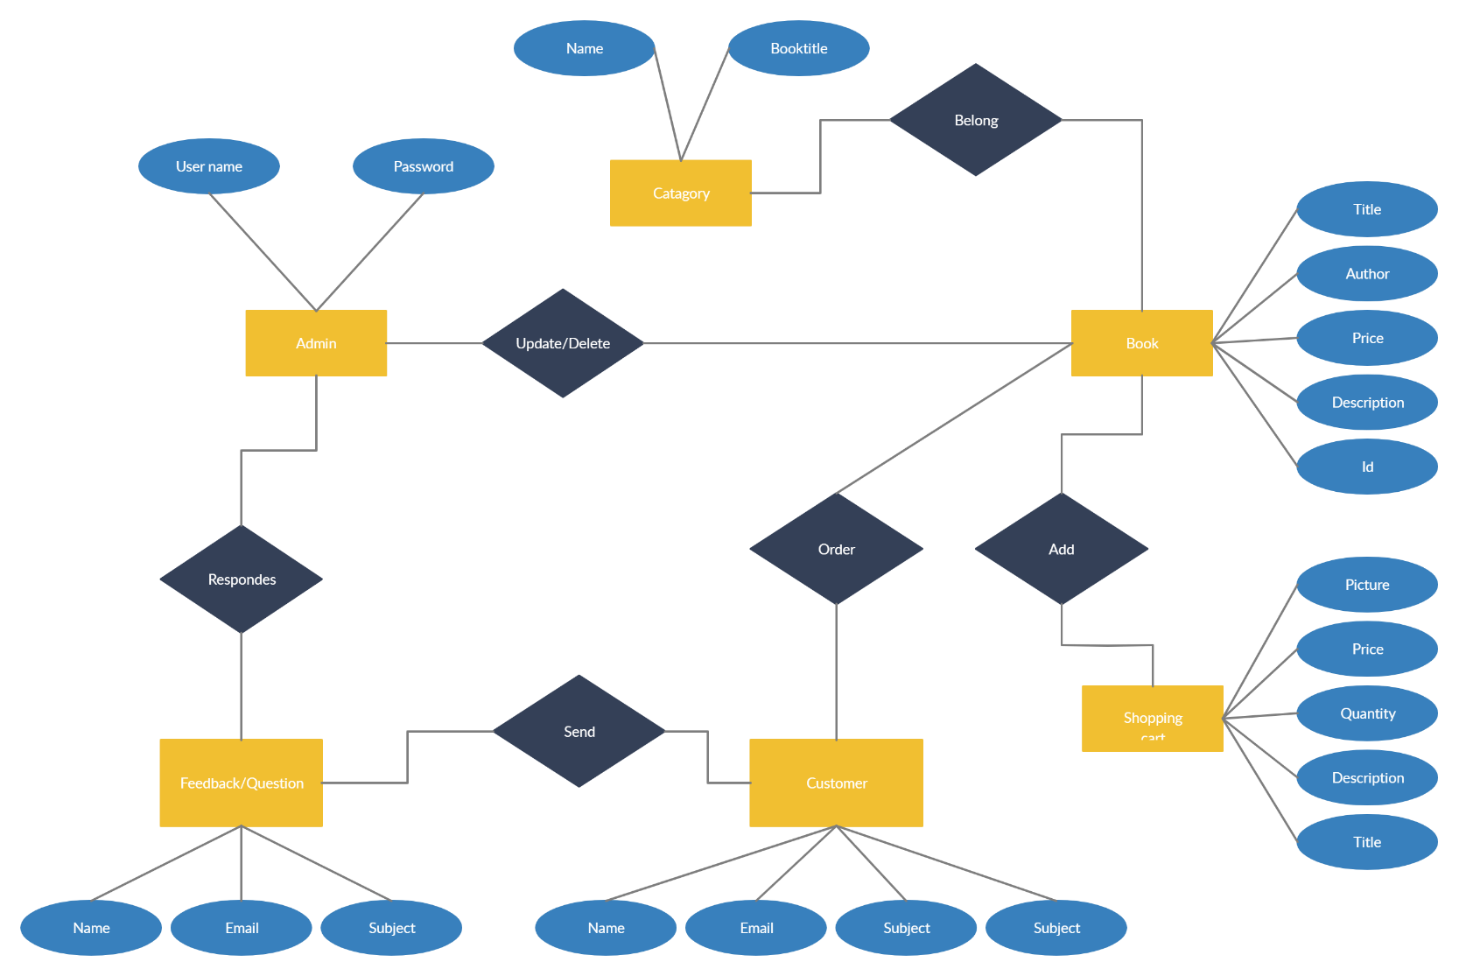

Figure. E-R Diagram

**Data Flow Diagram**

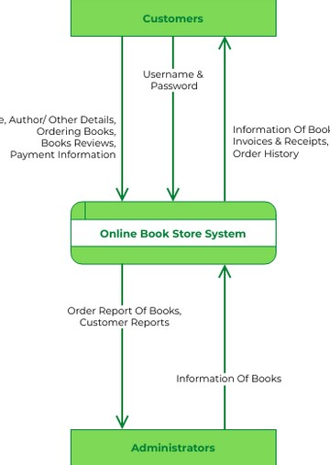

**TABLE OF CONTENTS**

|  |  |  |
| --- | --- | --- |
|  | **Title** | **Page No.** |
|  | Title Page  Declaration By the Candidate  Acknowledgement  Abstract  Objective  Problem Statement  E-R Diagram  Data Flow Diagram | I  II  III  IV  V  V  VII  VIII |
| 1. | INTRODUCTION  1.1 Project Overview  1.2 Background  1.3 Motivation  1.4 Key Components  1.5 Brief Overview | 1-4  1  2  2  3  4 |
| 2. | REVIEW OF LITERATURE  2.1 Existing Online bookstore  2.2 Technological Frameworks  2.3 Collaboration filtering techniques  2.4 Content based filtering  2.5 Hybrid recommendation system  2.6 Context aware recommendation system | 5-7  5  5  6  6  7  7 |
| 3. | PROBLEM DEFINATION AND OBJECTIVE  3.1 Problem Definition  3.2 Objective  3.2.1 Primary challenges  3.2.2 Secondary challenges  3.2.3 Research and analysis  3.2.4 Purpose of the project | 8-11  8  9  9  10  10  11 |

|  |  |  |
| --- | --- | --- |
| 4. | DESIGN AND IMPLEMENTATION  4.1 System Architecture  **4.1.1** Client-Side (Frontend)  4.1.2 API layer  4.2 Login Design  4.3 User Interface Design  4.3.1 Design principles  4.3.2 About Considerations | 12-17  12  13  13  14  15  16  17 |
| 5. | RESULT AND DISCUSSION | 18-28 |
| 6. | CONCLUSION AND FUTURESCOPE | 29-31 |
| 7. | REFERENCE | 31 |

### Table of Figures

|  |  |  |
| --- | --- | --- |
| **Figure No.** | **Title** | **Page No.** |
| 4.2.1 | Log in Page | 15 |
| 4.3 | Search Bar | 15 |
| 4.3.1 | New Arrivals | 16 |
| 4.3.2 | About Us | 17 |
| 5.1 | Home Page | 18 |
| 5.2 | About Us Page | 19 |
| 5.3 | Featured Books | 20 |
| 5.4 | New Arrivals | 21 |
| 5.5 | Registration Page | 22 |
| 5.6 | Login Page | 23 |
| 5.7 | Search Books | 24 |
| 5.8 | View Search Books | 25 |
| 5.9 | Read Books | 26 |

### Chapter 1 INTRODUCTION

Online book store are designed to suggest books to users based on their preferences and reading history. These systems are used by online bookstores, libraries, and other platforms to personalize the user experience and encourage exploration of new titles. The Book Recommendation System aims to provide the best suggestion to the user by analysing the buyer’s interest. The quality and the content are taken into consideration by employing content filtering, association rule mining and collaborative filtering.

An online book store system harnessing frontend technologies and APIs provides a sophisticated solution to navigate the vast digital library. Integrating a user-friendly frontend interface with the capabilities of APIs unlocks a wealth of book data, enabling users to unearth titles aligned with their unique tastes and preferences. Whether users are on the hunt for a particular book or venturing into uncharted literary territory, this system serves as an indispensable guide, streamlining the discovery process and fostering a personalized reading journey. The frontend interface presents an intuitive environment where users can seamlessly engage with the system. Through its responsive design and visually appealing layout, the interface enhances user experience, making book exploration a pleasurable endeavour. Behind the scenes, APIs such as the Google Books API serve as a treasure trove of information, furnishing the system with comprehensive details about millions of books, including titles, authors, descriptions, and cover images. By tapping into this vast reservoir of data, the system can generate tailored recommendations tailored to each user's unique tastes.

Moreover, the integration of additional APIs like Goodreads API or Amazon Product Advertising API supplements the recommendation process by incorporating user-generated reviews, ratings, and social interactions. This infusion of social proof and community feedback enriches the recommendation ecosystem, ensuring that users receive relevant and reliable suggestions. Ultimately, the online book store system acts as a trusted companion, guiding users on a personalized journey of literary discovery. With its seamless interface and access to comprehensive book data, the system empowers users to embark on a fulfilling reading experience, regardless of their location or literary preferences.

**1.1Project Overview**

The Online Book Store project is designed to address the increasing challenge of helping users discover relevant and engaging books in the vast world of digital literature. With the proliferation of online libraries and bookstores, users often find it overwhelming to identify books that align with their interests.

Our online book Store is like a helpful friend who suggests the perfect book for you to read. It's a smart system that uses technology to make finding great books easy and fun. Imagine you're in a huge library with millions of books.

The online book store system project aims to develop a sophisticated platform that assists users in discovering books tailored to their preferences and interests. Leveraging modern frontend technologies and APIs, the system provides a user-friendly interface for seamless interaction. Users can input their reading preferences, search for specific titles, or explore new genres, allowing for a personalized and enriching reading experience.

The project integrates with APIs such as the Google Books API to access comprehensive book data, including titles, authors, descriptions, and cover images. Additionally, the system may incorporate APIs like Goodreads API or Amazon Product Advertising API to enhance recommendations with user generated reviews and ratings. The project's objective is to create a robust recommendation engine that delivers accurate and relevant suggestions while maintaining user privacy and ethical considerations. Through intuitive design and efficient backend algorithms, the online book store system aims to revolutionize the way users discover and engage with literature in the digital age, fostering a vibrant community of readers and book enthusiasts.

**1.2 Background**

The exponential growth of digital libraries and e-commerce platforms has led to an overwhelming abundance of books available to readers. Consequently, users face the daunting task of sifting through this vast sea of literature to find works that align with their interests. Online book store systems serve as intelligent assistants, leveraging algorithms and data-driven approaches to provide tailored suggestions, thus enhancing the overall user experience.

The background of an online book store system utilizing frontend technologies and APIs stems from the need to navigate the vast digital landscape of literature effectively. With the exponential growth of online bookstores and digital libraries, users often face the challenge of sifting through an overwhelming array of titles to find books that align with their interests. Traditional methods of browsing or searching may not always yield satisfactory results, prompting the development of more sophisticated recommendation systems. Leveraging frontend technologies like React.js or Angular, these systems provide users with a user-friendly interface that simplifies book exploration and discovery. Additionally, by integrating APIs such as the Google Books API, these systems gain access to vast repositories of book data, including titles, authors, descriptions, and cover images. This integration enables the system to generate personalized recommendations tailored to each user's preferences, enhancing the overall user experience. Furthermore, the incorporation of APIs like Goodreads API or Amazon Product Advertising API augments the recommendation process by incorporating user-generated reviews, ratings, and social interactions, thereby enriching the recommendation ecosystem and ensuring more relevant and reliable suggestions.

**1.3 Motivation**

The motivation behind this research lies in addressing the limitations of existing online book store systems. While significant progress has been made in the field, challenges persist in terms of accuracy, diversity, and adaptability.

The motivation behind developing an online book store system that leverages frontend technologies and APIs stems from the desire to enhance the book discovery experience for users in the digital era. With the exponential growth of online libraries and bookstores, navigating the vast landscape of literature can be overwhelming.

By integrating a user-friendly frontend interface with powerful APIs, this system aims to simplify the process of finding relevant and engaging books tailored to each user's interests and preferences.

The primary motivation is to empower users with a personalized and enriching reading experience. Through the seamless integration of frontend technologies, such the system provides an intuitive platform where users can effortlessly explore, search, and discover new books. By harnessing the capabilities of APIs like the Google Books API, the system accesses a vast repository of book data, including titles, authors, descriptions, and cover images, enabling it to generate accurate and relevant recommendations.

**1.4 Key Components**

Understanding the architecture and components of the proposed system is crucial for grasping its functionality. This section provides an overview of the primary elements, such as user profiling, recommendation algorithms, and feedback mechanisms. A high-level system architecture is presented. An online book store system utilizing APIs and frontend technologies comprises several key components working seamlessly to provide users with personalized book suggestions. At its core is the frontend interface, developed using modern frameworks such as React.js or Angular, offering a user-friendly platform for interaction. This interface serves as the gateway for users to search for books, browse recommendations, and engage with the system's features effortlessly.

The backbone of the system lies in its integration with APIs, such as the Google Books API, which provides access to extensive book data including titles, authors, descriptions, and cover images. By leveraging these APIs, the system can retrieve and analyse relevant information, enabling it to generate tailored recommendations based on user preferences and interests.

Furthermore, user interaction and feedback play a crucial role in refining recommendations. The system may incorporate additional APIs like Goodreads API or Amazon Product Advertising API to gather user generated reviews, ratings, and social interactions, enriching the recommendation process with social proof and community feedback.

In summary, the key components of an online book store system using APIs and frontend technologies include the frontend interface for user interaction, APIs for accessing comprehensive book data, and mechanisms for gathering user feedback, all working together to deliver a personalized and enriching reading experience for users.

In summary, the key components of an online book store system using APIs and frontend technologies include the frontend interface for user interaction, APIs for accessing comprehensive book data, and mechanisms for gathering user feedback, all working together to deliver a personalized and enriching reading experience for users.

**1.5 Brief Overview**

An integration of an online book store system leveraging APIs, HTML, CSS, and JavaScript would entail several key components. HTML would structure the user interface, providing the framework for displaying book information and user interactions. CSS would handle the styling, ensuring a visually appealing and intuitive design. JavaScript would facilitate dynamic functionality, interacting with APIs to retrieve book data and generate recommendations based on user preferences or behaviour. The integration process would involve connecting to relevant APIs, such as those provided by book databases or recommendation engines, to fetch data such as book titles, authors, genres, and user reviews. JavaScript would then process this data, possibly implementing algorithms to tailor recommendations to individual users. The user interface would dynamically update to present these recommendations, allowing users to explore and discover new books tailored to their interests. Overall, this integration would create a seamless and interactive experience for users seeking personalized online book stores.

**Chapter 2**

### REVIEW OF LITERATURE

Online book store systems reveals a myriad of approaches integrating HTML, CSS, and JavaScript, often in conjunction with APIs for enhanced functionality. Various studies have explored the design and implementation of such systems, emphasizing user experience, algorithmic efficiency, and personalized recommendations. HTML and CSS are frequently employed for frontend development, providing the interface through which users interact with the system. JavaScript, on the other hand, plays a crucial role in handling dynamic content and enabling seamless interactions, such as real-time updates and asynchronous requests.

Additionally, the integration of APIs, such as those provided by book databases or recommendation services, significantly augments the system's capabilities by accessing vast repositories of book data and leveraging advanced recommendation algorithms. Through this integration, users can benefit from tailored suggestions based on their preferences, reading history, and social interactions, thereby enhancing their overall browsing and discovery experience. However, challenges such as scalability, data privacy, and algorithmic bias remain pertinent considerations in the development and deployment of these systems, warranting further research and refinement in pursuit of more robust and inclusive solutions.

**2.1 Existing Online book store System:**

* Review existing online book store system and analyse their features, functionalities, and technological frameworks.
* Explore how frontend technologies like HTML, CSS, and JavaScript, alongside connecting API, contribute to the development of these platforms.
* Assess how these platforms incorporate sections like "About Us" and "What We Do" to provide users with insights into the organization's mission and services offered, similar to the structure of your project.

* 1. **Technological Frameworks:**

Discuss the role of frontend technologies in building online book store system, considering your use of HTML, CSS, JavaScript, and Connecting API.

Evaluate the advantages and limitations of these technologies in facilitating efficient data storage, server communication, and user interaction.

5

* 1. **Collaborative Filtering Techniques:**

Collaborative filtering (CF) has been a cornerstone in the development of recommendation systems. Traditional collaborative filtering methods, such as user-based and item-based approaches, have been extensively explored. Recent studies have also delved into matrix factorization techniques, including singular value decomposition (SVD) and alternating least squares (ALS), offering improved scalability and performance.

Collaborative filtering stands as a cornerstone technique within online book store systems, seamlessly blending frontend interfaces and APIs to deliver personalized reading suggestions. At its core, collaborative filtering analyses user behaviour and preferences to generate recommendations based on similarities with other users. Frontend interfaces, constructed with contemporary frameworks like React.js or Angular, provide users with an intuitive platform to interact with the system. Through these interfaces, users can input their reading history, preferences, and ratings, thereby enabling the system to understand their unique tastes. Meanwhile, APIs such as the Google Books API serve as a vital conduit for accessing extensive book data, enriching the recommendation process with comprehensive information about titles, authors, and genres. By leveraging collaborative filtering, the system identifies users with similar reading habits and recommends books enjoyed by those with comparable tastes. This approach fosters a sense of community and discovery, allowing users to explore new literary realms guided by the preferences of likeminded readers. As users engage with the frontend interface and receive personalized recommendations powered by collaborative filtering, they embark on a journey of literary exploration tailored to their individual interests and preferences, enriching their reading experience.

* 1. **Content-Based Filtering Approaches:**

Content-based filtering methods have gained prominence by considering the intrinsic characteristics of books and user preferences. Natural Language Processing (NLP) techniques, such as text analysis and sentiment analysis, have been employed to extract meaningful features from book descriptions and user reviews, enhancing the system's ability to generate accurate recommendations based on content relevance. Content-based filtering approaches in an online book store system leverage both frontend technologies and APIs to deliver personalized book suggestions to users. These approaches analyse the content and attributes of books to generate recommendations based on similarities with users' preferences. Through the frontend interface, users provide input, such as book titles or genres of interest. These attributes with users’ historical interactions or explicit feedback, the system generates recommendations for books that share similar content or themes. This approach enables the system to deliver relevant and tailored suggestions, enriching users' reading experiences and fostering engagement with the platform. Additionally, the integration of frontend technologies ensures a seamless user experience, allowing users to effortlessly explore and discover books that resonate with their interests and preferences.

* 1. **Hybrid Recommendation systems**

Hybrid recommendation systems, combining collaborative filtering and content-based filtering, have demonstrated superior performance in overcoming the limitations of individual approaches.

By integrating collaborative filtering, content-based filtering, and possibly other recommendation methods, the system can provide more accurate and diverse book suggestions tailored to individual user preferences.

APIs such as the Google Books API or Goodreads API provide access to vast repositories of book data, including titles, authors, descriptions, and user-generated reviews. By tapping into this wealth of information, the system can enhance its recommendation process, ensuring that suggestions are not only personalized but also informed by user feedback and social interactions

* 1. **Context-Aware Recommendation System**

Context-aware recommendation systems consider additional contextual factors, such as time, location, and device, to enhance the relevance of recommendations. Studies suggest that incorporating context awareness improves the adaptability of recommendation systems to dynamic user preferences and situations.

The literature review of online recommendation systems provides a comprehensive overview of existing research, methodologies, and findings in the field. Scholars have extensively studied various aspects of recommendation systems, including algorithm development, user behaviour analysis, evaluation metrics, and ethical considerations.

In terms of algorithm development, collaborative filtering, content-based filtering, and hybrid approaches have been widely explored. Collaborative filtering techniques leverage user-item interaction data to make recommendations based on similarities between users or items. Content- based filtering, on the other hand, focuses on the attributes of items and user preferences to generate recommendations. Hybrid approaches combine these techniques to overcome their individual limitations and improve recommendation accuracy.

User behaviour analysis is another key area of research, aiming to understand user preferences, dynamics, and patterns. Researchers investigate factors such as user demographics, browsing history, purchase behaviour, and social interactions to enhance the personalization and relevance of recommendations.

7

**Chapter 3**

### PROBLEM DEFINATION AND OBJECTIVE

#### 3.1 Problem Definition

* **User Profiling:** Creating accurate and comprehensive user profiles is essential for understanding individual preferences. However, users may have diverse reading habits, varying tastes, and evolving interests, making it difficult to capture their preferences accurately.
* **Content Representation:** Books come in various genres, styles, and themes, each appealing to different segments of readers. Representing this diverse content effectively within the recommendation system requires sophisticated algorithms capable of capturing the nuances of literary works.
* **Algorithmic Complexity:** Developing recommendation algorithms that can analyze user behavior, historical data, and book characteristics to generate meaningful recommendations is a non-trivial task. Balancing the complexity of algorithms with computational efficiency is crucial for real-time recommendations and scalability.
* **Cold-Start Problem:** New users or books with limited historical data pose a challenge known as the cold-start problem. Recommending books to these users or promoting new releases requires innovative approaches to mitigate the lack of historical data.
* **Evaluation Metrics:** Assessing the effectiveness of recommendation systems is essential for measuring their performance and optimizing algorithms. Determining appropriate evaluation metrics that reflect user satisfaction, engagement, and diversity in recommendations is an ongoing challenge.

##### 3.1.1 Primary Challenges

The problem definition of an online book store system involves identifying and addressing the key challenges associated with recommending books to users in an online environment. This includes understanding the limitations of existing recommendation systems, recognizing user needs and preferences, and defining specific objectives for the system's development and implementation.

**Some of the primary challenges include**:

* **Data Sparsity and Cold Start:** Inadequate user interaction data or new users with no history pose challenges in generating accurate recommendations.
* **Scalability:** As the user base and book catalog grow, the system must scale efficiently to handle increased data volume and user requests.
* **Algorithmic Complexity:** Developing effective recommendation algorithms that balance accuracy, diversity, and serendipity while accounting for factors like user demographics, reading habits, and book content.

* **Evaluation Metrics:** Determining appropriate metrics to evaluate the performance of recommendation algorithms and ensure that they align with user satisfaction and engagement.
* **User Privacy and Ethical Concerns:** Safeguarding user privacy and ensuring that recommendation processes are transparent, fair, and free from biases or discrimination.
* **Integration with E-commerce Platforms:** Seamlessly integrating recommendation features with online bookstores or e-commerce platforms, facilitating smooth user experiences from recommendation to purchase.
* **Personalization vs. Diversity:** Striking a balance between personalized recommendations tailored to individual preferences and introducing diversity to encourage exploration of new genres, authors, and topics.

#### 3.2 Objective

The objective of an online book store system is to provide users with personalized and relevant suggestions for books they may enjoy, thereby enhancing their overall reading experience. Through advanced algorithms and user data analysis, the system aims to understand individual preferences, reading habits, and interests. By leveraging this information, it can generate recommendations tailored to each user, helping them discover new authors, genres, and titles that align with their tastes.

Additionally, the system seeks to simplify the process of book discovery and selection for users by presenting them with curated lists, personalized recommendations, and user- generated reviews. This not only saves time but also fosters a sense of community and engagement among readers.

Moreover, an online book store system aims to support online bookstores by increasing user engagement, retention, and ultimately sales. By connecting users with books they are likely to enjoy, the system can drive traffic to bookstores, boost conversion rates, and contribute to a thriving online book ecosystem. The objective of an online book store system is to enhance user satisfaction, promote literacy, and facilitate the exploration and enjoyment of literature in a digital age.

##### 3.2.1 Primary Objectives

These objectives are strategically formulated to address the identified challenges in existing systems and contribute to the enhancement of user satisfaction, system adaptability, and the overall quality of book recommendations. Develop and implement advanced recommendation algorithms, including collaborative filtering, content-based filtering, and hybrid approaches, to significantly improve the accuracy of book recommendations.

##### 3.2.2 Secondary Objectives

Implement strategies to diversify book suggestions, encouraging users to explore a wider range of genres, authors, and topics. This involves optimizing recommendation algorithms to balance popular and niche content, fostering a more comprehensive reading experience.

Develop and integrate a user feedback mechanism that allows users to provide explicit feedback on recommended books. Utilize this feedback to continuously refine the recommendation engine, ensuring it remains aligned with user preferences and expectations.

##### 3.2.3 Research and Analysis Objectives

This involves employing established evaluation metrics to assess accuracy, diversity, and computational efficiency. The research and analysis objectives of an online book store system encompass a broad spectrum of aims aimed at improving the effectiveness, efficiency, and user experience of the system. Firstly, research efforts often focus on understanding user behavior, preferences, and reading habits through data analysis and user studies. This involves identifying patterns in user interactions, exploring factors influencing book choices, and discerning user preferences across different genres, authors, and topics. Additionally, researchers strive to enhance the accuracy and relevance of recommendation algorithms by investigating advanced machine learning techniques, collaborative filtering methods, and content-based approaches. Furthermore, efforts are directed towards evaluating the performance and impact of recommendation strategies through rigorous experimentation and user feedback. This includes assessing metrics such as recommendation precision, diversity, novelty, and user satisfaction to gauge the system's effectiveness and identify areas for improvement. Moreover, research objectives extend to addressing emerging challenges and opportunities in the domain, such as the integration of social context, mitigating algorithmic bias, and adapting to evolving user preferences and trends. Research on online book store systems encompasses a wide range of topics aimed at improving the effectiveness, accuracy, and user satisfaction of such systems. Scholars investigate various aspects including algorithm development, user behavior analysis, and system Performance evaluation one focus of research is the refinement of recommendation algorithms, exploring techniques such as collaborative filtering, content- based filtering, and hybrid approaches to generate personalized recommendations. Additionally, researchers delve into user modeling and profiling, studying factors like reading habits, preferences, and demographics to better understand user needs and tailor recommendations accordingly. Evaluation methodologies are also a key area of study, with researchers developing metrics and benchmarks to assess the performance and relevance of recommendation systems. Furthermore, ethical considerations such as privacy protection, fairness, and transparency in recommendation processes are increasingly gaining attention. Overall, research in online book store systems aims to advance the state-of-the- art in recommendation technology, enhance user experiences, and address emerging challenges in the digital book ecosystem.

**3.2.4 Purpose of The Project**

* **Personalization:** Tailoring recommendations based on the user's historical reading behavior, preferences, ratings, and interactions with the platform. This personalization enhances user satisfaction by presenting relevant content that matches their tastes.
* **Discovery:** Facilitating the discovery of new and diverse books that users may not have encountered otherwise. Recommendation systems can introduce users to authors, genres, or topics they may be interested in exploring, thus broadening their reading horizons.
* **Efficiency:** Streamlining the book selection process by presenting users with a curated list of recommendations, saving time and effort spent on searching through vast collections or browsing extensive catalogues.
* **User Engagement:** Increasing user engagement and retention by providing valuable recommendations that keep users coming back to the platform. Engaging recommendations can foster a sense of loyalty and trust between the user and the platform.
* **Community Interaction:** Enabling social features such as user reviews, ratings, and recommendations from friends or like-minded readers. Social interactions enhance the recommendation system's effectiveness by incorporating social context and leveraging collective intelligence.

### Chapter 4 DESIGN AND IMPLEMENTATION

**4.1 System Architecture**

The system architecture of an online bookstore system utilizing frontend and connecting to an API is structured to seamlessly integrate user interaction, data retrieval, and recommendation generation. At its core, the architecture comprises three main layers: the client- side frontend, the API layer, and external APIs.

Starting with the client-side frontend, it serves as the interface through which users interact with the system. Developed using HTML, CSS, and JavaScript, the frontend presents the user with a visually appealing and intuitive interface. This includes components such as search bars, filters, and book displays, providing users with the means to explore and interact with book recommendations. JavaScript handles dynamic elements and interactions, facilitating real-time updates and responsive design to enhance user experience.

The API layer acts as an intermediary between the frontend and external APIs, managing data exchange and communication. It typically consists of an API gateway and various endpoints for handling frontend requests. The API gateway serves as a centralized entry point, managing authentication, routing, and rate limiting to ensure secure and efficient communication. Within the API layer, endpoints are responsible for fetching book recommendations and book data from external APIs, processing requests, and returning relevant information to the frontend. These endpoints may utilize RESTful or GraphQL APIs to facilitate communication between the frontend and external services.

External APIs play a crucial role in providing the system with access to book data and recommendation algorithms. These APIs, such as Google Books API or custom recommendation services, serve as the primary sources of book information and recommendation generation.

Through API requests, the system retrieves details about books, including titles, authors, descriptions, and reviews, as well as personalized recommendations based on user preferences and historical data. By connecting to external APIs, the system leverages existing resources and algorithms to enhance the quality and relevance of book recommendations.

The system architecture of an online bookstore system using frontend and API typically consists of several components that interact to provide users with personalized book recommendations.

Overall, the system architecture of an online bookstore system using frontend and connecting to an API emphasizes efficient data retrieval, seamless user interaction, and personalized recommendation generation.

Through the integration of frontend components, API communication, and external services, the architecture enables a cohesive and engaging user experience while leveraging external resources to provide tailored book recommendations. This architecture enables the separation of concerns between the frontend, backend, and external services, allowing for scalability, modularity, and flexibility in developing and maintaining the online bookstore system.

**4.1.2 Client-Side (Frontend):**

* **User Interface (UI):** The frontend component presents the user interface to the user, including search bars, filters, book displays, and recommendation results.
* **Interactivity:** JavaScript is used to handle dynamic interactions, such as fetching data from the API, updating the UI in real-time, and handling user inputs.
* **User Authentication:** If the system requires user accounts, authentication mechanisms like login and registration forms are implemented on the frontend.

**API Layer:**

* **API Gateway:** Acts as a centralized entry point for frontend requests to access backend services. It may handle authentication, routing, and rate limiting.
* **Recommendation API:** This API provides endpoints for fetching book recommendations based on user preferences, historical data, and recommendation algorithms. It may integrate with third-party recommendation services or utilize custom algorithms.
* Book Data API: Connects to external book databases or services to retrieve detailed information about books, including titles, authors, descriptions, covers, and reviews.
* **User Management:** Handles user authentication, authorization, and profile management, including storing user preferences and reading history.

**4.1.3 External APIs:**

* **Book Data Providers:** Interfaces with external APIs like Google Books API, Goodreads API, or custom book databases to fetch book information, reviews, ratings, and metadata.
* **Authentication Services:** Utilizes external authentication services like OAuth providers for user authentication and authorization.
* **Integration and Communication:**

Frontend communicates with the API layer via HTTP requests (e.g., RESTful APIs) or WebSocket for real-time updates.

Backend services interact with databases and external APIs to fetch and store data as needed.

* **Deployment:**

Frontend, API layer, and backend services are deployed on web servers or cloud platforms like AWS, Azure, or Google Cloud Platform

**4.2 LOG IN Design**

* **User Registration:** Allow users to create an account by providing their email address, username, and password. Implement validation to ensure unique usernames and strong passwords. Store user credentials securely in a database.
* **Login Form:** Create a login form with fields for the user to enter their username/email and password. Implement client-side validation to ensure the fields are not empty.

**Authentication:** Upon form submission, authenticate the user by verifying their credentials against the stored data in the database. If the username/email and password match, generate a session token or set a cookie to keep the user logged in.

* **Session Management:** Implement session management to track user authentication status across pages. Store session tokens securely and validate them on subsequent requests to determine if the user is authenticated.
* **Error Handling:** Provide appropriate error messages for invalid login attempts, such as incorrect username/password or inactive accounts. Display error messages to the user to indicate the reason for login failure.
* **User Dashboard:** After successful login, redirect the user to their dashboard or homepage. The dashboard may include personalized book recommendations, reading history, profile settings, and other user-specific content.
* **Logout Functionality:** Implement a logout mechanism to allow users to securely end their session. This typically involves destroying the session token or clearing the authentication cookie.
* **Security Measures:** Implement security best practices to protect user credentials and sensitive data. Use HTTPS to encrypt data transmitted between the client and server. Implement measures such as password hashing and salting to securely store user passwords.
* **User Experience:** Design the login process to be user-friendly and intuitive. Provide clear instructions and feedback to guide users through the login process.
* **Testing:** Thoroughly test the login functionality to ensure it works as expected under various scenarios, including valid and invalid inputs, different browsers, and devices.
* **Security Measures:** Implement security best practices to protect user credentials and sensitive data. Use HTTPS to encrypt data transmitted between the client and server. Implement measures such as password hashing and salting to securely store user passwords.
* **User Experience:** Design the login process to be user-friendly and intuitive. Provide clear instructions and feedback to guide users through the login process.

* **Testing:** Thoroughly test the login functionality to ensure it works as expected under various scenarios, including valid and invalid inputs, different browsers, and devices.

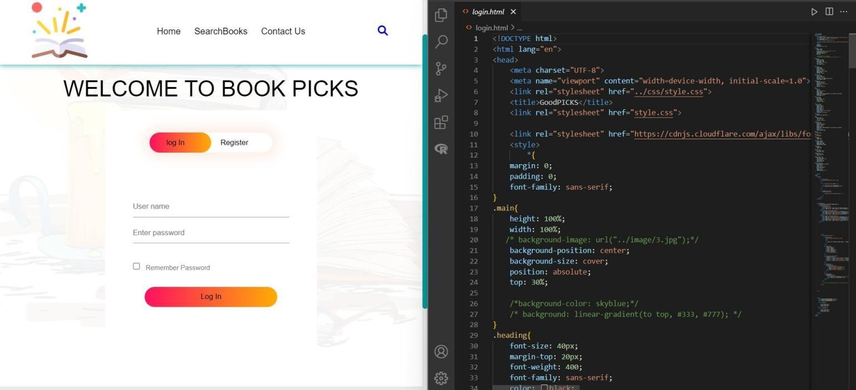

Figure 4.2 Login Page

**4.3 User Interface Design**

The user interface design of the search bar in an online bookstore system is a critical element for facilitating user interaction and enhancing the overall user experience. The search bar serves as the primary gateway for users to explore the vast library of books available on the platform. Therefore, it should be prominently positioned within the interface, typically at the top of the page, and feature a clean and intuitive design.

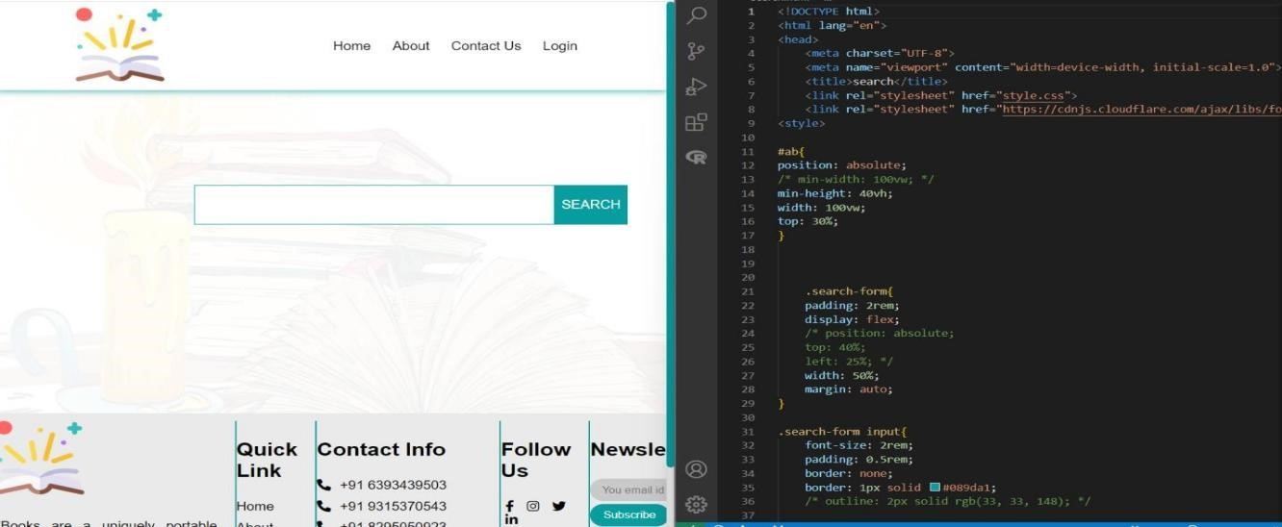

Figure 4.3 Search Bar

**Design Principles:**

The design principles of the search bar in an online bookstore system are crucial for facilitating efficient book discovery and enhancing user experience. Firstly, the search bar should be prominently placed within the user interface, ensuring visibility and accessibility across all pages of the platform. It should feature a clean and intuitive design, with clear labelling and placeholder text to guide users on how to interact with it effectively. Autocomplete or suggestion features can aid users in formulating their queries, reducing typing effort and improving search accuracy.

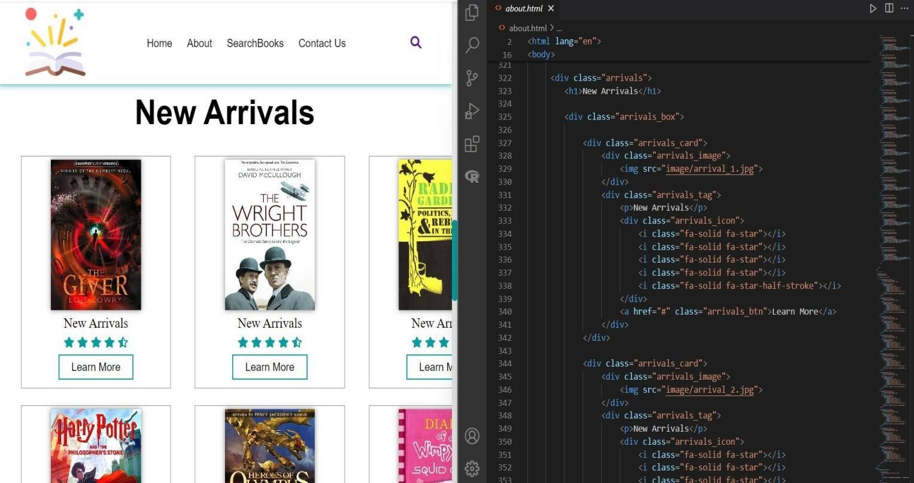

Figure 4.3.1 New Arrivals

**About Considerations:**

The "About Us" section of an online bookstore system serves as a window into the platform's mission, values, and goals. It typically outlines the team behind the system, their expertise, and the motivation driving the development of the platform. This section might highlight the dedication to fostering a vibrant reading community by providing personalized book recommendations tailored to individual preferences and interests.

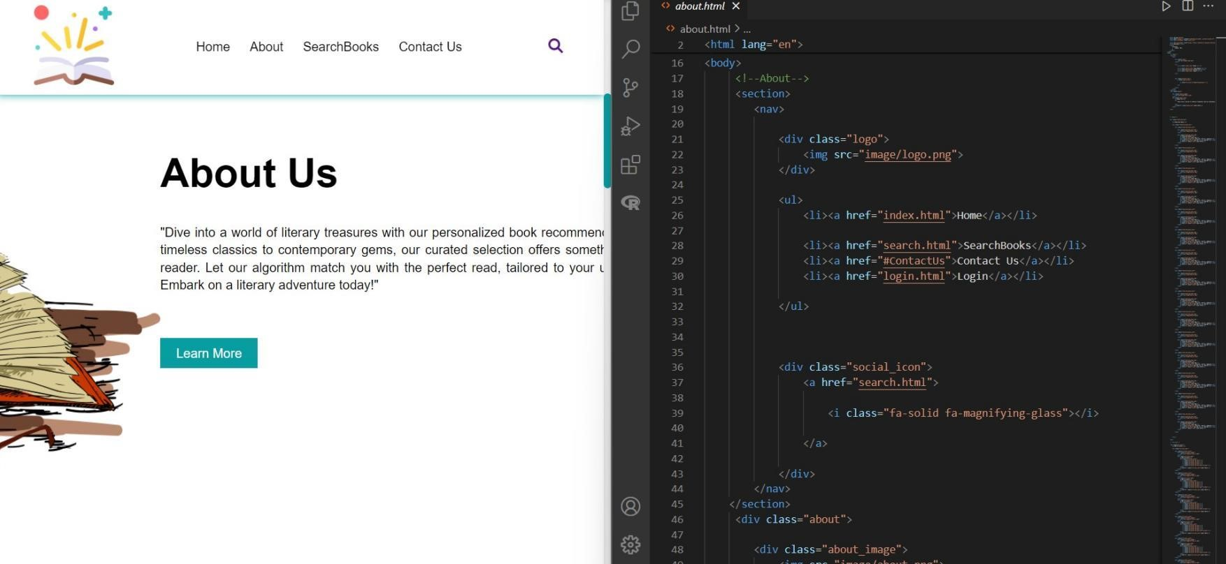

Figure 4.3.2: About us

### Chapter-5 RESULT AND DISCUSSION

**Home Page:**

The homepage of a book recommendation system serves as the gateway for users to explore and discover new books tailored to their interests. The navigation bar at the top of the page provides easy access to essential features and sections of the platform, ensuring intuitive user interaction. It typically includes links to key areas such as the user's profile, book categories, recommendations, and a search bar. The search bar is a prominent feature on the homepage, allowing users to quickly find books by entering keywords, authors, or genres of interest. It provides a convenient way for users to initiate book discovery based on their specific preferences, ensuring a personalized and efficient browsing experience.

The homepage prominently features a "Search Books" button, inviting users to explore the platform's vast catalogue and discover new reading material. This button could be accompanied by engaging visuals, such as book covers or recommendations, to capture users' attention and encourage interaction.



Figure 5.1 Home Page

**About Us Page:**

Welcome to our Book Recommendation System! We are a team passionate about literature and technology, dedicated to revolutionizing the way readers discover their next favorite book. Our platform is designed to provide personalized recommendations tailored to your unique tastes and preferences. In the "About Us" section of a website dedicated to book recommendations, users typically find detailed information about the platform, its purpose, and the team behind it. This section serves as a means to introduce the website to visitors and provide insights into its objectives and values.

The "About Us" section serves as a testament to our ongoing commitment to innovation and excellence. We continuously strive to enhance our recommendation algorithms, user experience, and community engagement initiatives. By sharing our story and values, we aim to forge meaningful connections with our users, fostering a sense of belonging and shared passion for the written word.



Figure 5.2: About us Page

**Featured Books:**

"Featured Books" serves as a dynamic showcase within the book recommendation system, highlighting a curated selection of new and noteworthy titles. This section offers users a glimpse into the latest trends, releases, and discoveries in the world of literature, curated specifically to capture their interest and curiosity. By regularly updating the featured books, the recommendation system ensures that users are exposed to a diverse range of genres, authors, and themes, fostering exploration and discovery. Each featured book is carefully chosen based on its relevance, popularity, and potential appeal to the platform's audience, providing users with a curated browsing experience that encourages engagement and excitement. Whether it's introducing users to emerging voices, bestsellers, or hidden gems, the "Featured Books" section plays a pivotal role in driving user engagement, facilitating book discovery, and enriching the overall reading journey within the recommendation system.

The "Featured Books" section offers a convenient starting point for browsing and discovery, especially for users seeking inspiration or looking to explore new genres or authors. It provides a snapshot of the latest additions or highlights within the platform's extensive catalogue, saving users time and effort in finding compelling reads**.**



Figure 5.3: Featured Books

**New Arrivals:**

The "New Arrivals" section leverages real-time data feeds or periodic updates to ensure that users have access to the freshest content available. It may employ algorithms that prioritize recently published books based on factors such as popularity, user engagement, and relevance to individual user preferences. Additionally, the section might incorporate features such as personalized recommendations tailored to each user's reading history and interests, further enhancing the relevance of new arrivals.

By providing easy access to new books, the "New Arrivals" feature enriches the overall book discovery experience, catering to users who are eager to explore the latest literary offerings. It serves as a dynamic and engaging component of the recommendation system, fostering user engagement, retention, and satisfaction. Furthermore, the "New Arrivals" section contributes to the platform's mission of promoting literacy, supporting authors, and facilitating the enjoyment of literature in the digital age.



Figure 5.4: New Arrivals

**Register Page:**

The register page of the book recommendation system serves as the gateway for users to create their accounts and access the platform's personalized features. Users are prompted to input essential information such as a username, email address, and password to set up their accounts. The username allows users to personalize their profiles and interact with the platform under a recognizable identity. The email address serves as a unique identifier and facilitates communication between the platform and the user, such as account verification, password resets, and important notifications. The password, preferably encrypted and securely stored, ensures the protection of user accounts from unauthorized access, The register page can feature user-friendly design elements and clear instructions to guide users through the registration process seamlessly.

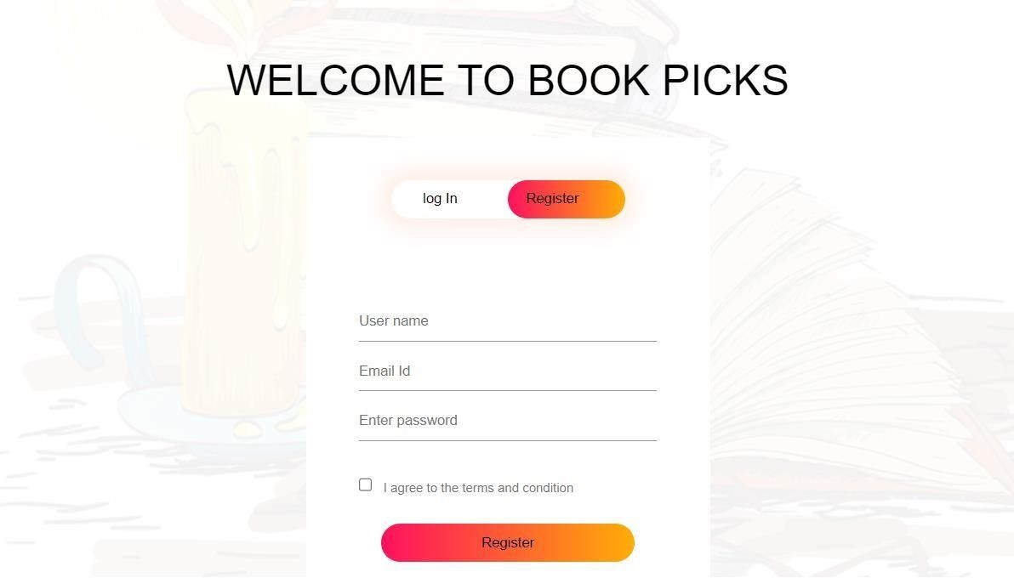

Figure 5.5: Registration Page

**Login Page:**

The login page serves as the gateway to accessing the features and personalized recommendations offered by the online bookstore system. It typically prompts users to enter their username or email ID along with their password to authenticate their identity and gain access to their account. This authentication process ensures the security and privacy of user data, safeguarding personal information and reading preferences stored within the system.

By requiring users to input their username or email ID, the login page enables seamless access for returning users, allowing them to pick up where they left off in their book discovery journey.

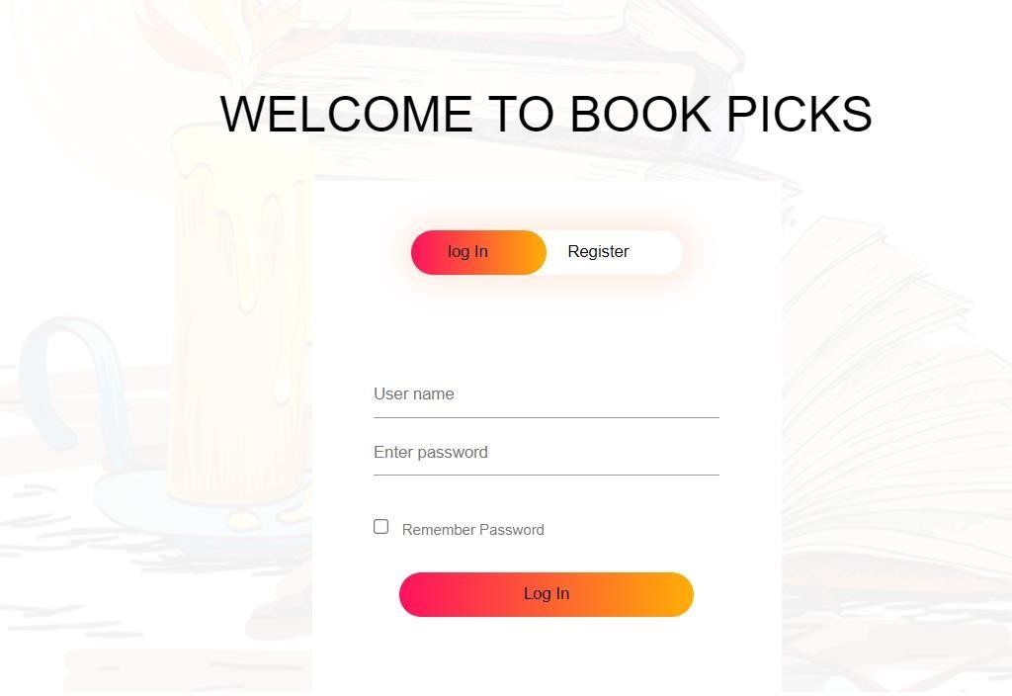

Figure 5.6: Login Page

**Search Books:**

The "Search Book" feature in a book recommendation system serves as a fundamental tool for users to explore a diverse range of books aligned with their interests and preferences. This feature enables users to discover new titles, authors, genres, and topics by conducting searches based on specific keywords, genres, authors, or other criteria. It provides users with a seamless and intuitive way to navigate through the extensive catalogue of books available on the platform.

The "Search Book" functionality, users can initiate their exploration journey by inputting relevant keywords or phrases related to the books they are interested in. For example, users might search for specific genres like "mystery," "science fiction," or "romance," or they might look for books by their favourite authors or titles.

The system then retrieves and presents a list of relevant book recommendations based on the search query, leveraging sophisticated search algorithms and indexing techniques to ensure accuracy and relevance.



Figure 5.7: Search Books

**View Search Books:**

The "View/Search Books" feature is a fundamental component of a book recommendation system, enabling users to explore and discover a diverse range of books tailored to their interests. This functionality allows users to input the name of a book they are interested in, and the system responds by displaying relevant books that align with their search query. By leveraging advanced search algorithms and a vast database of books, this feature enhances the user experience by providing quick and accurate results.

Users can utilize this feature to search for specific titles, authors, genres, or keywords, allowing them to explore books that match their preferences and interests. Whether users are looking for a particular book they heard about, exploring a new genre, or simply browsing for inspiration, the "View/Search Books" feature empowers them to find relevant recommendations efficiently.



Figure 5.8: View Search Books

**Read Books:**

The essence of a book recommendation system lies in its ability to facilitate the discovery of relevant books based on user interests and preferences. Users can input the names of books they have enjoyed or are interested in, and the system generates recommendations that align with their tastes. This process simplifies the task of finding new books to read, particularly for users who may not be familiar with the vast array of available literature.

They're looking for fiction, non-fiction, or a specific genre, the system provides tailored suggestions that cater to their individual tastes. By presenting users with a curated selection of books, the system helps them discover new authors, explore different genres, and broaden their reading horizons.

The book recommendation system serves as a valuable tool for readers seeking to expand their literary repertoire. By leveraging user input and sophisticated algorithms, the system empowers users to discover and enjoy books that match their interests and preferences, ultimately enriching their reading experience.

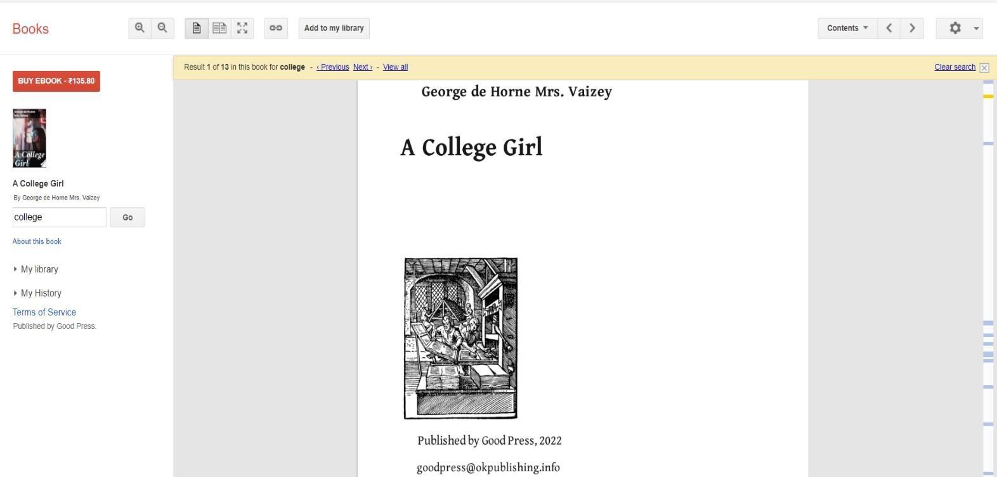

Figure 5.9: Read Books

**DISCUSSION**

An online bookstore system using a front-end interface and Google API is a sophisticated tool that leverages modern web technologies to deliver personalized book suggestions to users. At the core of this system is the front-end interface, typically developed using web technologies such as HTML, CSS, and JavaScript. This interface is designed to be user- friendly, providing a seamless and interactive experience. Users can enter their preferences, search for specific titles, or browse genres, which the system uses to tailor recommendations.

The real power of the system lies in its integration with Google APIs, particularly the Google Books API. This API provides access to a vast database of books, including metadata like titles, authors, publishers, and even snippets of book content. By interfacing with Google Books API, the recommendation system can fetch detailed information on a wide array of books, enhancing the quality and relevance of the recommendations provided. Furthermore, machine learning algorithms can be applied to analyse user data and reading patterns, allowing the system to refine its suggestions over time, making them increasingly personalized.

Such a system not only enhances user engagement by making it easier to find books that match their interests but also supports publishers and authors by increasing visibility for a diverse range of titles. Overall, an online bookstore system that combines a sleek front-end with robust API integration like

Google’s creates a dynamic platform that enriches the reading experience for users across the globe.

This API allows the recommendation system to fetch detailed information about books, including titles, authors, publishing dates, descriptions, and even previews. It can query a vast database of books, making it possible to provide recommendations based on a comprehensive dataset. For example, if a user likes a particular author or genre, the system can quickly retrieve other books with similar characteristics.

The recommendation results are then fetched using the Google Books API, enriching the data with detailed information about each recommended book. This enriched data is sent back to the front-end, where it is dynamically displayed to the user. Creating an online bookstore system using frontend technologies and Google APIs can be a fascinating project that leverages modern web development tools and the vast data handling capabilities of Google. Below, I’ll guide you through key aspects of this project, including design considerations, technological components, and implementation strategies.

1. **Project Overview**

The aim is to build a system that can recommend books based on user preferences, search histories, or specific input criteria. This system would use frontend technologies for user interaction and Google APIs to fetch book data, user reviews, and other relevant information.

1. **Key Components**

**a. Frontend Technologies**

HTML/CSS/JavaScript: Basic building blocks for web pages. HTML structures the content, CSS styles it, and JavaScript adds interactivity. **b. Google APIs**

**Google Books API:** This API allows you to access the vast amount of book data stored in Google’s servers, including titles, authors, publishing info, reviews, and ratings.

Google Analytics API: Useful for tracking user interactions and behaviours on the site, which can be vital for improving the recommendation engine. **3. Design Considerations**

1. **User Interface (UI)**

**Simplicity and Accessibility:** The interface should be clean and easy to navigate. Accessibility features include keyboard navigability and screen reader support.

**Responsive Design:** The site should be usable on any device, adjusting layout as needed for different screen sizes.

1. **User Experience (UX)**

**Search and Filter:** Users should be able to search for books based on different criteria (genre, author, etc.) and have features to refine their searches.

**Recommendations:** Based on user activity and preferences, dynamically suggest books. This could be done through collaborative filtering or more complex machine learning techniques. Feedback System: Allow users to rate and review books, which can feed back into the recommendation engine to improve suggestions.

### 4. Implementation Strategy

**a. API Integration**

**Fetching Data:** Use the Google Books API to fetch book information. You might need to handle API keys and manage request quotas.

**Displaying Results:** Parse the API response and display the results in a user-friendly format on your frontend.

**5. Challenges and Solutions**

**a. Scalability**

Ensure the frontend can handle large amounts of data without performance lag. Techniques like lazy loading, pagination, or infinite scrolling can be beneficial. **b. API Limitations**

Google APIs might have usage limits. Handle these gracefully in your application, possibly caching data or implementing error handling that informs the user of any issues.

### Chapter 6 CONCLUSION

In conclusion, developing an online bookstore using HTML, CSS, JavaScript, and PHP creates a robust platform that offers users a seamless and enjoyable shopping experience. The front-end technologies, HTML and CSS, enable the creation of a visually appealing and user-friendly interface. From structured product listings to an intuitive checkout process, these elements ensure that users can easily navigate the store. JavaScript further enhances the platform’s interactivity, enabling real-time features such as live search, dynamic cart updates, and personalized browsing experiences.

On the back end, PHP plays a crucial role in handling server-side functionalities such as user authentication, secure data processing, and integration with the MySQL database for storing and managing user accounts, product inventories, and transaction records. To ensure security and trust, features like password encryption, input validation, and SSL certificates are implemented, protecting sensitive user information and payment data.

The system’s capabilities can be enhanced with the integration of third-party APIs such as Google Books or Goodreads. These APIs allow the store to offer enriched content, including book descriptions, author details, ratings, and reviews, improving the user experience. Personalized recommendations and promotions can also be introduced using algorithms based on customer preferences and purchase history. Thorough testing ensures the platform’s performance across various devices and browsers, addressing potential issues before deployment. Scalability is another important aspect, allowing the store to accommodate growing inventories and user bases over time.

By combining a visually appealing front-end, a secure and efficient back-end, and value-added features like personalized recommendations and API integrations, this online book store meets the demands of modern e-commerce. It offers a convenient, reliable, and engaging platform for book enthusiasts, empowering them to explore and purchase books effortlessly from anywhere in the world.

**FUTURE SCOPE**

The future scope of a basic book recommendation system that incorporates Razor pay for transactions and leverages full-stack development can be expansive and transformative for the book industry. This type of system, which integrates e-commerce capabilities and robust data management into a book discovery platform, could potentially revolutionize how readers interact with and purchase books online. Here, we'll explore the potential enhancements, integrations, and advancements that could shape the future of such a system.

1. **Enhanced Personalization**

Future developments could focus on refining the algorithms used for book recommendations. By employing more sophisticated machine learning models that analyze user behavior, preferences, and feedback, the system can offer increasingly accurate and personalized book suggestions. Integration of natural language processing (NLP) could also allow the system to understand and process user reviews and sentiments about books, thereby improving recommendation accuracy based on qualitative data.

1. **Expanded Database and Metadata Management**

To support a growing and evolving inventory of books, ongoing efforts in database management will be critical. Future versions could expand the metadata stored for each book, including not only basic bibliographic information but also reader demographics, historical popularity trends, and cross-references to similar books. This would enhance the richness of the recommendations and could be used to create specialized collections or themes that cater to diverse user interests.

1. **Seamless Integration of E-commerce**

With Razor pay, the system already has a robust payment gateway integrated. Future developments could streamline and enhance the e-commerce aspect by incorporating features like dynamic pricing, sales promotions, and personalized discounts. Additionally, integrating logistics APIs to handle real-time shipping updates and inventory management could provide a seamless buying experience from recommendation to delivery.

1. **Social Features and Community Building**

Integrating social features would allow users to share their reading experiences, write reviews, and recommend books to peers within the platform. Features like reading groups, live author chats, and community-driven book clubs could transform the platform into a social hub for book lovers, thus increasing user engagement and retention.

1. **Multi-platform Accessibility**

Expanding the system to be accessible across multiple platforms, including mobile apps, e-readers, and desktop applications, would enhance accessibility and convenience. Ensuring that the user interface is responsive and intuitive across all platforms would cater to the varied preferences of users, making book discovery and purchase a seamless experience regardless of device

30

### REFERENCES

1. Bobadilla J, Ortega F, Hernando A and Gutierrez A, Recommender systems survey, Knowledge- Based Systems, 46 (2013) 109
2. Ramos J, using tf-idf to determine word relevance in document queries, In Proceedings of the First Instructional Conference on Machine Learning, 2003.
3. Rana C and Jain S K, building a book recommender system using time based content filtering, WSEAS Transactions on Computers, 11 (2) (2012) 27-33
4. Francesco Ricci, Lior Rokach, and Bracha Shapira. Introduction to recommender systems handbook.
5. Badrul Sarwar et al. “Item-based collaborative filtering recommendation algorithms.” In: Proceedings of the 10th international conference on World Wide Web. ACM. 2001pp. 285–295.
6. Li H, Gu Y and Koul S, Review of digital library book recommendation models, Available at <http://dx.doi.org/>10.2139/ssrn.1513415
7. Pera M S, Nicole C and Ng Y K, Personalized book recommendations created by using social media data, In Chiu D K W et al, Web Information Systems Engineering – WISE
8. Online bookstore system Conference Paper · September 2015 DOI: 10.1109/ICECCO.2015.7416895